Capstone Project The Battle of the Neighborhoods

Liefeng Xiao

July 22,2020

1. **Introduction**

**1.1 Background**

London is one of the most prosperous and cultural city in the world. It had very developed service sectors. So, it is no wondered that someone wants to open a new Italian restaurant in the center of London to catch the trend and make a lot of money.

* 1. **Problem**

This project aims at finding the optimal selection for a new-opened Italian restaurant in the London city center. The core factors to influence our decision are the number of restaurants, number of Italian restaurant and the distance to the city center.

* 1. **Interest**

It is obvious that the stake holders are the people who want to operate an Italian restaurant in the London city center.

1. **Data acquisition and cleaning**

**2.1 Data sources**

There three main factors to determine the location of the restaurant.

1. number of restaurants existing in the neighborhoods
2. number of similar Italian restaurants in the neighborhoods
3. distance of neighborhoods from city center

The coordinate of the city center can be acquired by using **geopy library in Python.**

Number of restaurants and their type and other type of buildings can be obtained by **Foursquare API**

The neighborhoods data can also be acquired by **Foursquare API**

**2.2 Neighborhood Candidates**

First find the location of the London Center (longitude=-0.1276474, latitude=51.5073219)

Then Create a grid of cells covering our area of interest which is aprox.12x12 km centered around London city center.

Table 1: city center location and candidate neighborhood centers

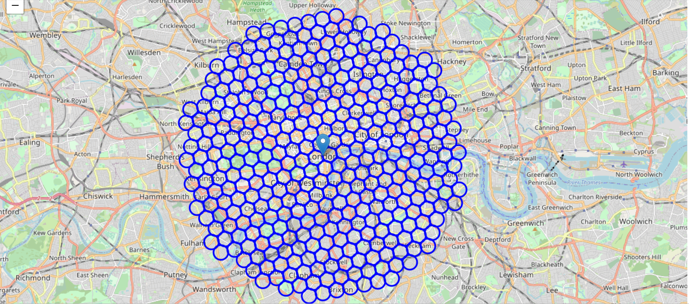

Next use the **geopy library to get the** approximate addresses of those locations

Table 2: Dataframe of the generated locations

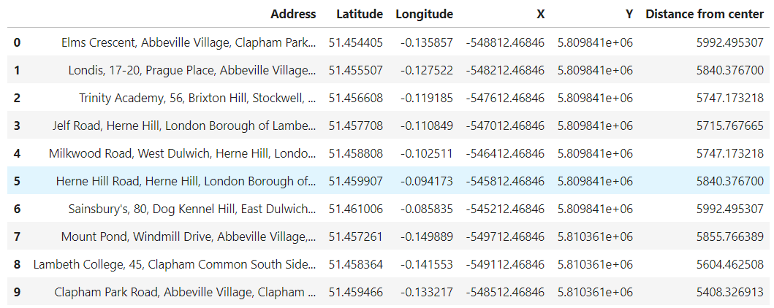

In the next stage the FourSquare API is used to get information on restaurants in each neighborhood.

Table 3: Maps of the restaurants in the city center and the Italian restaurants(red points)

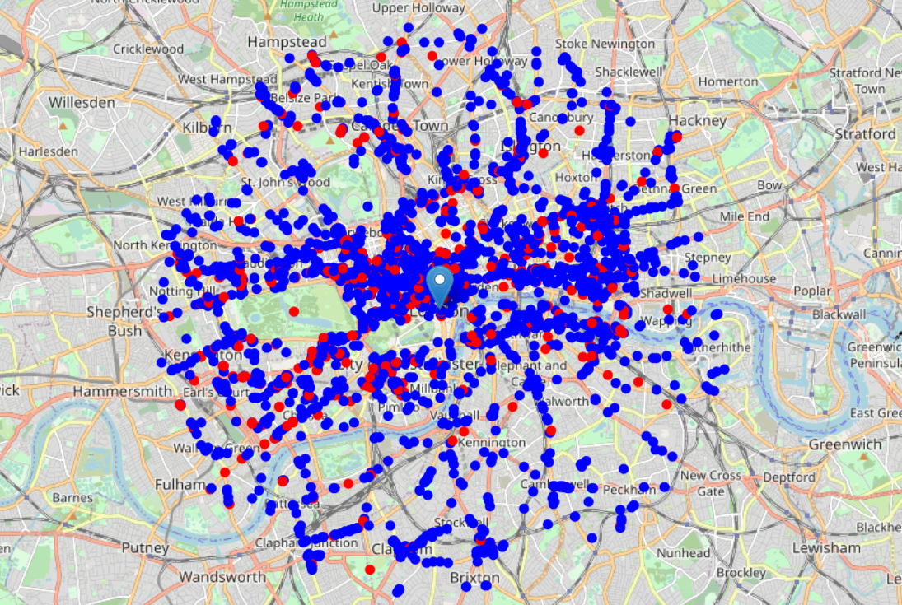

1. **Exploratory Data Analysis**

**3.1 Methodology**

In this project we will direct our efforts on detecting areas of London that have low restaurants density.

In first step we collected the required data location and type of every restaurants within 6km from London center. We also identified Italian restaurants.

Second step in the analysis will be the calculation and exploration of ‘restaurant density’ across different areas of London-use heatmaps to identify a few promising areas close to center with low number of restaurants in general and focus our attention on those areas.

In the third and final step we focus on most promising areas and within those create clusters of locations that meet some basic requirements established in discussion with stakeholders we will take into consideration locations with **no more than two restaurants in radius of 250 meters**, and we want locations **without Italian restaurants in radius of 400 meters**. We will present map of all such locations but also create clusters (using **k-means clustering**) of those locations to identify general zones / neighborhoods / addresses which should be a starting point for final 'street level' exploration and search for optimal venue location by stakeholders.

* 1. **Analysis**

First we count the number of restaurants in every area candidate

Table4:Dataframe to show the number of restaurants near the neighborhoods

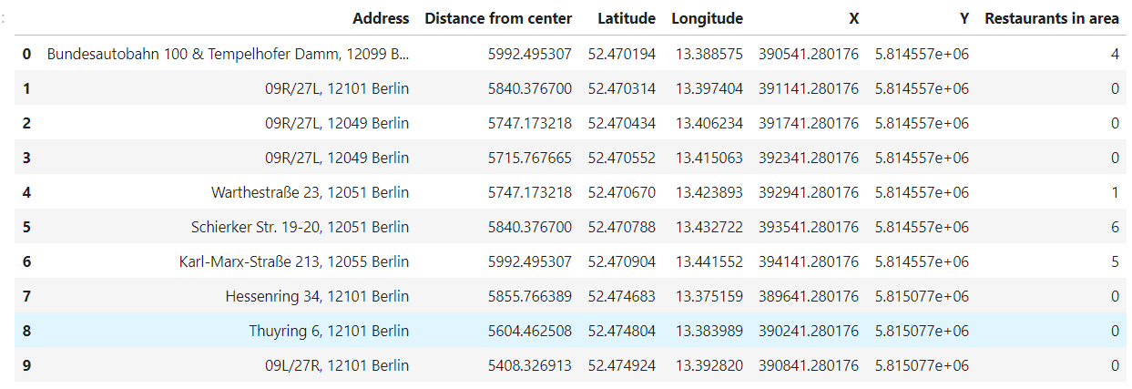

Then we calculate the distance to nearest Italian restaurant from every area candidate center.

Table5:Dataframe to show the **distance to nearest Italian restaurant**

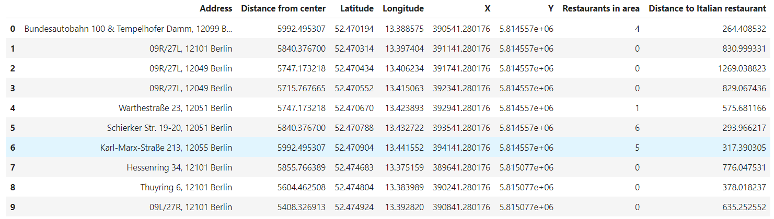

Table 6:Heatmap to show density of restaurants and also the borders of London borough

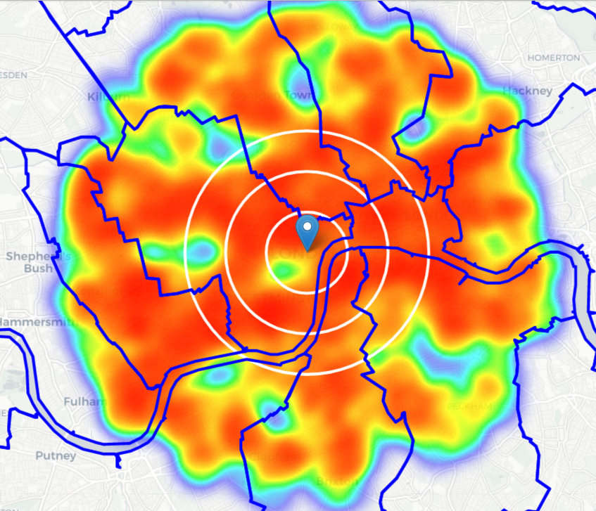

Table 7:map of the density of Italian restaurants

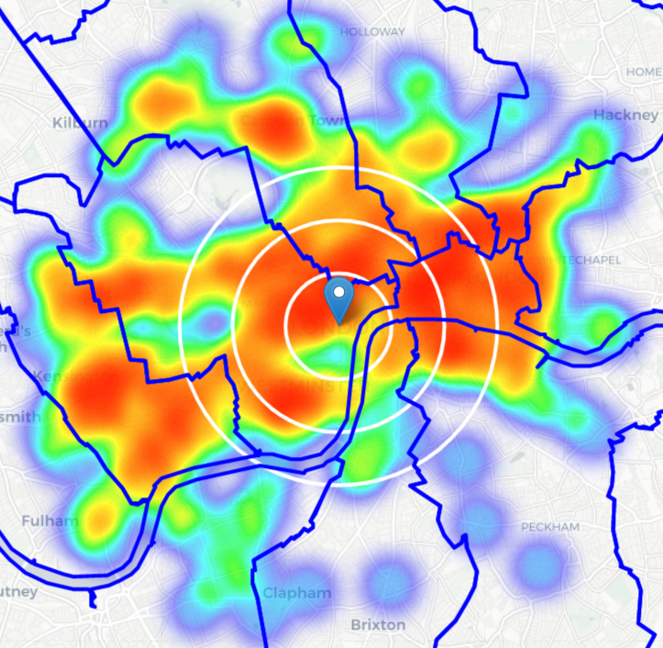

From above maps we can easily get that the south and the south east area has the least restaurants and Italian restaurants

* 1. **Pimlico and Kennington**

Pimlico:

''Pimlico is an area of Central London in the City of Westminster, built as a southern extension to neighbouring Belgravia.It is known for its garden squares and Regency architecture. It is demarcated to the north by Victoria Station, and bounded by the River Thames to the south, Vauxhall Bridge Road to the east and the former Grosvenor Canal to the west. At its heart is a grid of residential streets laid down by the planner Thomas Cubitt, beginning in 1825 and now protected as the Pimlico Conservation Area. Additions have included the pre-World War II Dolphin Square and the Churchill Gardens and Lillington and Longmoore Gardens estates, now conservation areas in their own right. The area has over 350 Grade II listed buildings and several Grade II* listed churches.''(From Wikipedia)

Kennington:

''Kennington is the location of three significant London landmarks: the Oval cricket ground, the Imperial War Museum, and Kennington Park. Its population at the United Kingdom Census 2011 was 15,106. Kennington is served by Kennington Police Station.''(From Wikipedia)

Large population, Popular with tourists,near the city center,these borough appear to justify further analysis.

Next we will focus on these two borough.

Table 8:maps of low-restaurant-count parts of Pimlico and Kennington

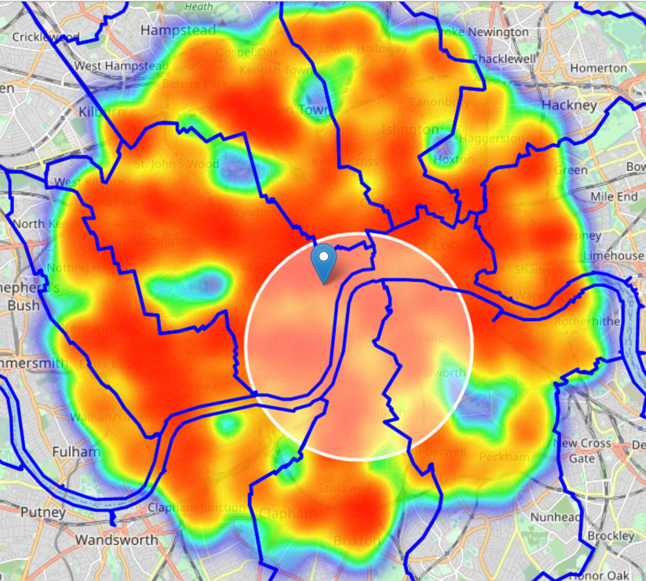

* 1. **Further Analysis**

First calculate  two most important things for each location candidate: **number of restaurants in vicinity** and distance to closet Italian restaurants

Table 9:Number of restaurants in vicinity and distance to closet Italian restaurants

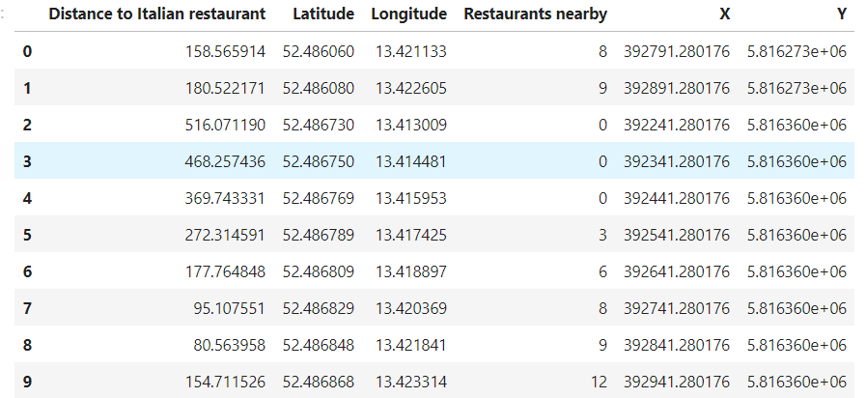

Then **filter** those locations: we're interested only in**locations with no more than two restaurants in radius of 250 meters,** and **no Italian restaurants in radius of 400 meters.**

Table 10:Maps of a clear indication of zones with low number of restaurants in vicinity, and no Italian restaurants at all nearby.

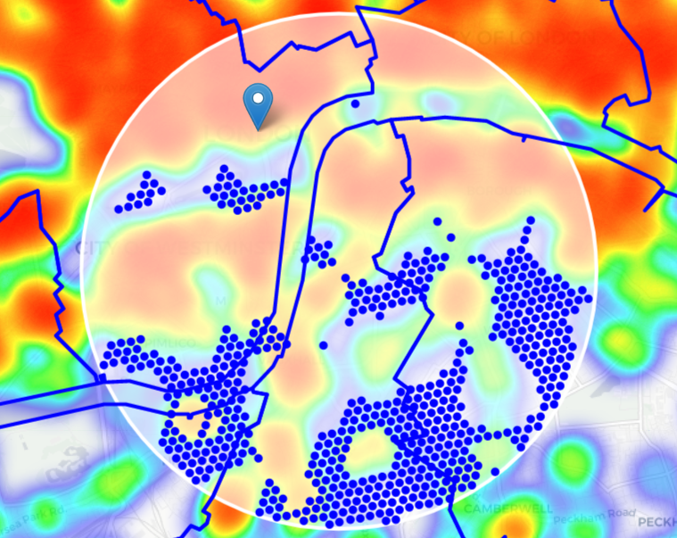

In the last **cluster** those locations to create **centers of zones containing good locations**. Those zones, their centers and addresses will be the final result of our analysis.

Table 11:Maps of cluster analysis

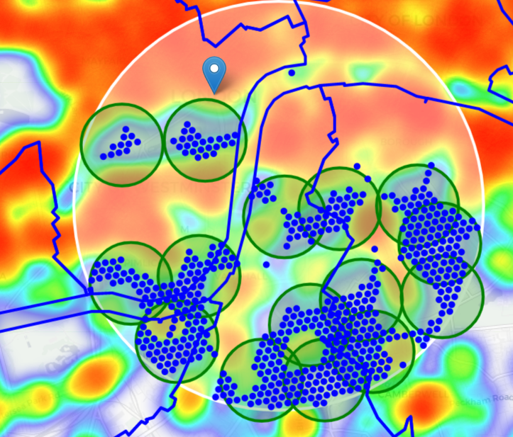

Finally, let's **reverse geocode those candidate area centers to get the addresses** which can be presented to stakeholders.

Table 12: Addresses of centers of areas recommended for further analysis

ARK All Saints Academy, 140, Wyndham Road, Wyndham and Comber Estate, Camberwell, London Borough of Southwark, London, Greater London, England, SE5 0UB, United Kingdom => 3.7km from London

Blackstone House, Glasgow Terrace, Pimlico, City of Westminster, London, Greater London, England, SW1V 3AB, United Kingdom => 2.5km from London

West Square, Borough, Elephant and Castle, London Borough of Southwark, London, Greater London, England, SE11, United Kingdom => 2.1km from London

English Martyrs' Catholic Primary School, Elsted Street, Bermondsey Spa, Walworth, London Borough of Southwark, London, Greater London, England, SE17, United Kingdom => 3.3km from London

Foreign and Commonwealth Office, 30, King Charles Street, Westminster, Millbank, City of Westminster, London, Greater London, England, SW1A 2AH, United Kingdom => 0.6km from London

Hampson Way, Stockwell, London Borough of Lambeth, London, Greater London, England, SW8 1HZ, United Kingdom => 3.6km from London

Michael Faraday Primary School, Portland Street, Borough, Walworth, London Borough of Southwark, London, Greater London, England, SE17, United Kingdom => 3.8km from London

Ponton Road, Nine Elms, London Borough of Wandsworth, London, Greater London, England, SW11 7BA, United Kingdom => 3.1km from London

Buckingham Palace Garden, Duke of Wellington Place, St. James's, Belgravia, City of Westminster, London, Greater London, England, SW1X 7SH, United Kingdom => 1.3km from London

Globe Academy, Harper Road, Borough, Walworth, London Borough of Southwark, London, Greater London, England, SE1 6AG, United Kingdom => 2.9km from London

Purple Jay Nursery, Juxon Street, South Bank, Lambeth, London Borough of Lambeth, London, Greater London, England, SE11 6NH, United Kingdom => 1.7km from London

Brixton Road, Kennington, London Borough of Lambeth, London, Greater London, England, SE11 5TP, United Kingdom => 3.1km from London

Lorrimore Square, Borough, Elephant and Castle, London Borough of Southwark, London, Greater London, England, SE17 3QU, United Kingdom => 3.1km from London

Christ Church Primary, Cancell Road, Kennington, London Borough of Lambeth, London, Greater London, England, SW9 6HN, United Kingdom => 3.8km from London

Here is the end of our analysis. It concludes 15 addresses which has lower number of restaurant and no Italian restaurant nearby. All this zones are near the city center(less than 4km). All the zones are showing on map with 500m radius. Most of these zones are located at Kennington and Pimlico which is identified as interesting due to being popular with tourists, fairly close to city center and well connected by public transport.

**4.Results and Discussion**

r analysis shows that although there is a great number of restaurants in London, there are pockets of low restaurant density fairly close to city center. Highest concentration of restaurants was detected middle and west from London, so we focused our attention to areas south, south-east and east, corresponding to Pimlico and Kennington.Our attention was focused on Pimlico and Kennington which offer a combination of popularity among tourists, closeness to city center, strong socio-economic dynamics and a number of pockets of low restaurant density.

After directing our attention to this more narrow area of interest we first created a dense grid of location candidates (spaced 100m appart); those locations were then filtered so that those with more than two restaurants in radius of 250m and those with an Italian restaurant closer than 400m were removed.

Those location candidates were then clustered to create zones of interest which contain greatest number of location candidates. Addresses of centers of those zones were also generated using reverse geocoding to be used as markers/starting points for more detailed local analysis based on other factors.

Result of all this is 15 zones containing largest number of potential new restaurant locations based on number of and distance to existing venues - both restaurants in general and Italian restaurants particularly. This, of course, does not imply that those zones are actually optimal locations for a new restaurant! Purpose of this analysis was to only provide info on areas close to London center but not crowded with existing restaurants (particularly Italian) - it is entirely possible that there is a very good reason for small number of restaurants in any of those areas, reasons which would make them unsuitable for a new restaurant regardless of lack of competition in the area. Recommended zones should therefore be considered only as a starting point for more detailed analysis which could eventually result in location which has not only no nearby competition but also other factors taken into account and all other relevant conditions met.

## 5.Conclusion

Purpose of this project was to identify London areas close to center with low number of restaurants (particularly Italian restaurants) in order to aid stakeholders in narrowing down the search for optimal location for a new Italian restaurant. By calculating restaurant density distribution from Foursquare data we have first identified general boroughs that justify further analysis (Pimlico and Kennington), and then generated extensive collection of locations which satisfy some basic requirements regarding existing nearby restaurants. Clustering of those locations was then performed in order to create major zones of interest (containing greatest number of potential locations) and addresses of those zone centers were created to be used as starting points for final exploration by stakeholders.

Final decission on optimal restaurant location will be made by stakeholders based on specific characteristics of neighborhoods and locations in every recommended zone, taking into consideration additional factors like attractiveness of each location (proximity to park or water), levels of noise / proximity to major roads, real estate availability, prices, social and economic dynamics of every neighborhood etc.